RCS Capstone Electrical Components

**Pressure transducer**

– spec sheet in Appendix A

Quantity = 1

Manufacturer Ashcroft

Part# G2 M01 15 F2 5000#

input voltage: 9-36Vdc

output voltage: 1-5Vdc

supply current 4: mA

**Purpose**

The pressure transducer will be used to measure remaining mass of N2 during flight for delta v calculations.

**Time Sampling**

Sample rate should be no less than 10 Hz

**Data Transferred**

The pressure transducer will output a voltage that needs to be interpreted as the pressure remaining in the tank

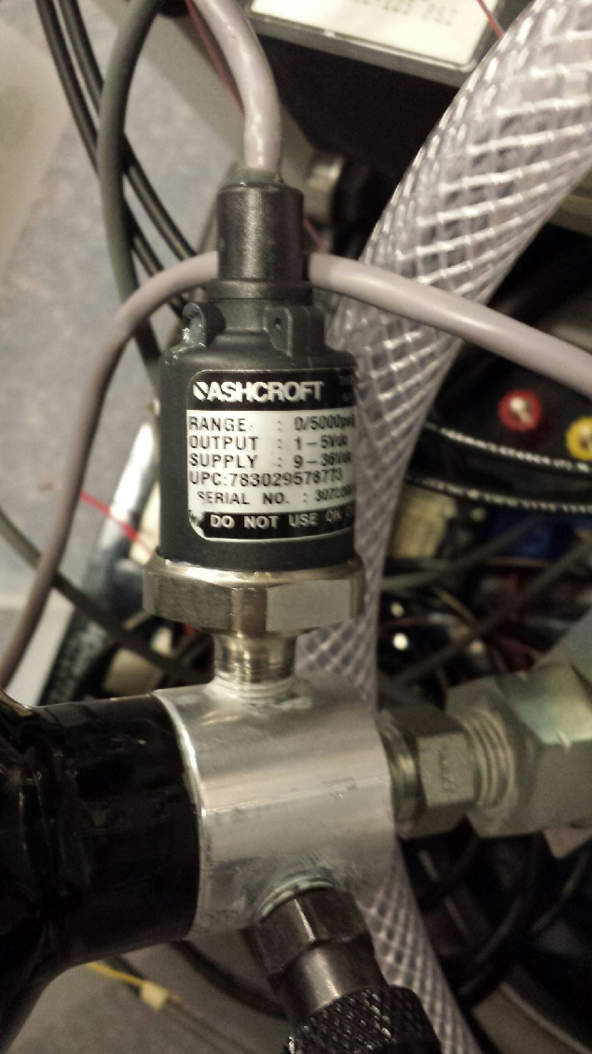

**Connections**

There are four wires inside a shielded cable. Red and Black are for input voltage and White and grey for output.

**System Location**

The pressure transducer is located at the nozzle of the gas tank and has a 2 ft cable.

**Solenoids**

– spec sheet in Appendix B

Quantity: 6

Model# 320

Manufacturer: Humprey

Electrical Specs

Voltage: 24V DC w/ range of +10% and -15%

Resistance: 72 Ohms

Current: 333mA

Power Consumption: 8 W max draw

Response time: on - 0.018 s, off - 0.009 s

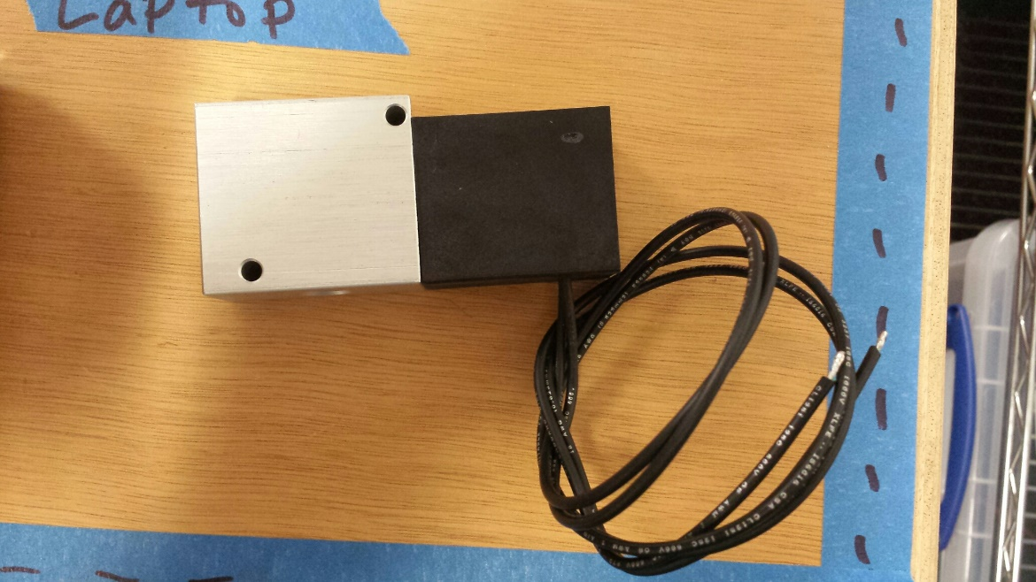

**Purpose**

The solenoids will be actuated to a given range of duty cycle by the rocket’s computer using a control algorithm.

**Temperatures**

Ambient temperature range: 32 F to 125 F

**Connections**

There are two 24 in black lead wires 18 AWG.

Humphry spec sheet on the 3rd page mentions two different connectors that can be ordered.

**Appendix A – Pressure Transducer Data Sheet**

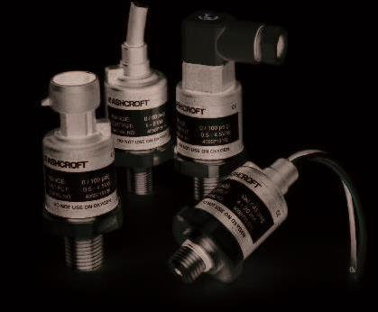

Cable

Connection

Hirschmann

Connection

Metri-Pack

Connection

Flying Lead

Connection

**Model G2 Pressure Transducer**

**APPLICATONS**

***The G2 pressure transducer combines***

***performance with value to meet the***

***demanding needs of the original equip-***

***ment manufacturer in applications***

***found in:***

***• Off-road Equipment***

***• Construction Machinery***

***• Performance Racing***

***• Railroad/Transportation***

***• Compressor Control***

***• HVAC and Refrigeration***

***• Agricultural Implements***

***• Process Automation and Control***

***• Hydraulic & Pneumatic Sensing***

***• Pump Monitoring***

**FEATURES**

***• 1% Total Error Band Accuracy***

***• Broad Temperature Capability***

***• All-welded pressure construction***

***• High EMI/RFI rating***

***• Ranges 30 psi through 20,000 psi***

***• IP 67 Ingress rating***

***• Diagnostic rails***

**PERFORMANCE SPECIFICATIONS**

Ref. Condition 21°C ±1°C (72°F ±2°F)

**Accuracy:**

Total Error Band includes combined effects of temper-

ature, non-linearity (Terminal Point Method), hysteresis,

non repeatabilty, zero offset and span setting errors

**±1% of Span:** From –20 to 85ºC (–4 to 185ºF)

**±1.5% of Span:** From –40 to –20ºC (–40 to –4ºF)

**±1.5% of Span:** From 85 to 125ºC (185 to 257ºF)

**Note:** Static accuracy ±0.25% of span BFSL (Best Fit

Straight Line Method); includes non-linearity,

hysteresis and non-repeatable effects at reference

temperature 72°F (21°C)

**Stability:** Less than ±0.25% span/year

**Durability:** Tested to 50 million cycles

**ENVIRONMENTAL SPECIFICATIONS**

**Temperature:**

Compensated –40 to 125°C (–40 to 257°F)

Operating –40 to 125°C (–40 to 257°F)

Storage –40 to 125°C (–40 to 257°F)

**Humidity:** 0 to 100% R.H., no effect

**FUNCTIONAL SPECIFICATIONS**

Select from over 25 pressure ranges starting at 30

psi and running through 20,000 psi gauge.

Compound (vacuum & pressure) ranges are also

available, see “To Order” on back.

**Overpressure (F.S.): Proof Burst**

750 psi & below 200% F.S. 1000% F.S.

1500 psi 200% F.S. 500% F.S.

3000 psi 200% F.S. 500% F.S.

5000 psi 150% F.S. 500% F.S.

7500 psi 120% F.S. 500% F.S.

10,000 psi 120% F.S. 240% F.S.

20,000 psi 120% F.S. 240% F.S.

**Vibration:** Random vibration (20 g) over tempera-

ture range (–40° to 125°C). Exceeds typical MIL.

STD. requirements

**Shock:** 100gs, 6 ms

**Drop Test:** Withstands 1 meter on concrete 3 axis

**Response Time:** Less than 1 msec

**Warm-up Time:** Less than 500 msec typical

**Position Effect:** Less than ±0.01% span, typical

**ELECTRICAL SPECIFICATIONS**

**Output Signals Available:**

**Supply**

**Voltage Output Excitation Current**

0-5 Vdc, 3 wire 9-36 Vdc 5mA

0-10 Vdc, 3 wire 14-36 Vdc 5mA

1-5 Vdc, 3 wire 9-36 Vdc 4mA

1-6 Vdc, 3 wire 9-36 Vdc 4mA

0.5-4.5Vdc, 3 wire 9-36Vdc 4mA

**Ratiometric Output:**

0.5-4.5 Vdc, 3 wire 5 Vdc ±0.5 Vdc 3.5mA

**Current Output:**

4-20mA, 2 wire 9-36 Vdc

**Reverse Polarity & Miswired Protected:** Yes

**Insulation Breakdown Voltage:** 100 Vac

**Insulation Resistance:** Greater than 100 megohms

at 100 Vdc

**CE Marked:** Per DoC

**EMC** Directive **2004/108/EC**

IEC/EN 61326-1:Edition 1.0 Industrial

IEC/EN 61326-2-3:Edition 1.0 Annex BB Industrial

**TOTAL ERROR BAND (TEB)**

**Error limits of all points (0-100% of range)**

**Ambient Temperature (C)**

**-60 -40 -20 0 20 40 60 80 100 120 140**

**2.0%**

**1.5%**

**1.0%**

**0.5%**

**0.0%**

**-0.5%**

**-1.0%**

**-1.5%**

**-2.0%**

**Pos Error Limit**

**Neg Error Limit**

The Ashcroft® Type G2† pressure transducer

has been specifically designed with the high

volume OEM in mind.

A ±1% Total Error Band accuracy is accom-

plished by marrying a high performance ASIC

to a very stable, field proven polysilicon thin

film pressure sensor. The sensor is electron

beam welded to a pressure fitting of stainless

steel, which provides excellent overpressure

capability and outstanding durability in the

presence of shock and vibration.

The circuitry is held within an internal cage

and housed in an enclosure of reinforced Nylon.

**LOOK FOR THIS**

**AGENCY MARK ON**

**OUR PRODUCTS**

**PED** Directive

BULLETIN G2

Ashcroft Inc., 250 East Main Street, Stratford, CT 06614 USA

Tel: 203-385-0648 • Fax: 203-385-0408

email: info@ashcroft.com • www.ashcroft.com

All specifications are subject to change without notice.

All sales subject to standard terms and conditions.

© 2013 Ashcroft Inc., Rev. 07/14



10 40

9 (min) 36 (max)

**Loop Supply Voltage (Vdc)**

**[LSV]**

**Power Supply Voltage vs. Loop Resistance**

**(4-20mA ONLY)**

**1400**

**1200**

**Model G2 Pressure Transducer**

BULLETIN G2

**How To Order**

**G 2 7 X**

**Type**

**Configuration**

(G2)

**Pressure Connection**

**Electrical Termination**

**Accuracy**

1.0% Total Error Band

–20°C/+85°C

1.5% Total Error Band

–40°C/-20°C, 85/125°C

**05** = 0-5 Vdc

**10** = 0-10 Vdc

**15** = 1-5 Vdc

**16** = 1-6 Vdc

**42** = 4-20mA

**45** = 0.5-4.5Vdc

9-36Vdc supply

**RM**= 0.5-4.5 Vdc

Ratio Metric to

5Vdc supply

Consult Factory for

Available Options

**Pressure Ranges Optional**

**X-Variations**

**M01**1⁄8NPT-male

**M02** 1⁄4NPT-male

**MEK** 7⁄16-20 SAE-male

w/Buna-N O-ring

**M38** 3⁄8-24 SAE-male

w/Buna-N O-ring

**MEV**9⁄16-18 SAE-male

w/Buna-N O-ring

**M33**3⁄8-24 UNJF3A (w/37° cone seat)

**M76** 7⁄16-20 UNJF-3A (w/37° cone seat)

**MS2**1⁄4-19 bsp male

**MG2**G 1⁄4B male

Consult factory for other connections

**psi Ranges**

**30#**= 30 psi

**50#**= 50 psi

**60#**= 60 psi

**100#**= 100 psi

**150#**= 150 psi

**200#**= 200 psi

**300#**= 300 psi

**400#**= 400 psi

**500#**= 500 psi

**750#**= 750 psi

**1000#**= 1000 psi

**1500#**= 1500 psi

**2000#**= 2000 psi

**3000#**= 3000 psi

**4000#**= 4000 psi

**5000#**= 5000 psi

**6000#**= 6000 psi

**7500#**= 7500 psi

**10000#**= 10000 psi

**15000#**= 15000 psi

**20000#**= 20000 psi

**Metri-Pack\***

**GN** = no mating conn.

**G2** = mating conn. 3´ cable

**G3** = mating conn. 10´ cable

**G1** = mating conn. w/customer

specified length

**Hirschmann G Series\*\***

**HM** = no mating conn.

**M1** = with mating conn. no cable

**M2** = mating conn. 3´cable

**P9** = mating conn. w/customer

specified length

**Flying Leads**

**W2** = 3´flying leads

**W9** = customer specified length

**Shielded Cable**

**F2** = 3´shielded cable

**F3** = 10´shielded cable

**P1** = customer specified length

**M12 –Mates to Hirschmann**

**933 172-100 or similar**

**EW** = w/o mating conn.

**E0** = w/mating conn. no cable

**E2** = w/mating conn. &

3´shielded cable

**E1** = w/mating conn. &

**Deutsch DT Series DT04-3P**

**DT** = w/out mating conn.

**T2** = w/1m, 3´cable

**T3** = w/3m, 10´cable

**T1** = w/mating conn. cable

customer defined length

**Deutsch DTM Series DTM04-3P**

**DS** = w/out mating conn.

**S2** = w/1m, 3´cable

**S3** = w/3m, 10´cable

**S1** = w/mating conn. cable

customer defined length

**AMP Superseal**

**AP** = w/out mating conn.

**A2** = w/1m, 3´cable

**A3** = w/3m, 10´cable

**A1** = w/mating conn. cable

customer defined length

**EN 175301-803, Form C**

**(DIN 43650, Form C)**

**DC** = no mating conn.

**N1** = with mating conn. no cable

**N2** = mating conn. 3´cable

**N3** = mating conn. 10´cable

**N9** = mating conn. w/customer

specified length

**Output Signal Measurement Type**

**G**= Gauge Pressure

**VdcMIN = 9V + [0.022AX (RL]**

RL= RS+ RW

RL= Loop Resistance (ohms)

RS= Sense Resistance (ohms)

RW= Wiring Resistance (ohms)

**Compound Ranges**

**30#&vac**= 30 psi/-14.7 psi

**45#&vac**= 45 psi/-14.7 psi

**60#&vac**= 60 psi/-14.7 psi

**85#&vac**= 85 psi/-14.7 psi

**100#&vac**= 100 psi/-14.7 psi

**150#&vac**= 150 psi/-14.7 psi

**200#&vac**= 200 psi/-14.7 psi

**300#&vac**= 300 psi/-14.7 psi

**PHYSICAL SPECIFICATIONS**

**Wetted Materials:** 304SS pressure connection and

17-4PH SS sensor diaphragm

**Housing:** 20% Glass Reinforced Nylon,

Fire retardant to UL94 V1

**Available Process Connections (Male):**

See “How To Order” section below. For other

connections consult factory.

**Ingress Rating:**

• IP67, NEMA 4X:

- Metri-Pack I50 series*

- Shielded cable

- Flying leads

- Deutsch DT Series DT04-3P

- Deutsch DTM Series DTM04-3P

- AMP Superseal

- M12 - Mates to Hirschmann 933 172-100 or similar

• IP65, NEMA 4X:

- Hirschmann G series**

- EN 175301-803, Form C (DIN 43650, Form C)

**ELECTRICAL TERMINATION**

See “How To Order” section below for electrical

termination options.

**DIMENSIONS**

customer defined length

Ashcroft Inc., 250 East Main Street, Stratford, CT 06614 USA

Tel: 203-385-0648 • Fax: 203-385-0408

email: info@ashcroft.com • www.ashcroft.com

All specifications are subject to change without notice.

All sales subject to standard terms and conditions.

© 2013 Ashcroft Inc., Rev. 07/14

1.40

1.59

.23

.94

1.06

(27)

1.06

(27)

(36)

MINI HIRSCHMANN**

(24)

.94

(24)

.71

(18) 2.24

(57)

(6)

2.05

(52)

.30 (8)

.23

(6)

(40)

Wire

Length

AMP SUPERSEAL DEUTSCH DT04-3P DEUTSCH DTM04-3P 3-PIN METRI-PACK*

.23

Ø.94 2.03

.45

1.02

1.06 .54

2.11

.56

.23

.94

.95

1.13

1.06

.44

.23

2.04

.46

Ø.94

1.06

.81

.67

Optional

Mating

Connector

Optional

Mating

Connector

Mates to Metri-Pack

Connector Body 12065286

Mates to Hirschmann G4W1F

Connector or Similar

**EN 175301-803, Form C**

**(DIN 43650, Form C)**

**M12 4-POLE PLUG**

Ø0.95

[Ø24.0]

1.69

[42.9]

1.74

[44.2]

2.60

[65.9]

0.23

[5.7]

1/4 NPT

**Connection - PIN**

**Vs+**

**1**

**V out 3 2**

**Vs-**

3.992 TYP

Install height

Pin 1

Pin 3 Pin 2

Pin 4

**Metri-Pack is a trademark of Delphi Packard Electric Systems.

**Trademark of Richard Hirschmann of America, Inc.

**Appendix B – Solenoid Data Sheet**

